Strictly Private & Confidential

DATE 04/01/2021

To whom it may concern,

RE: Essential Worker

I write to confirm that INSERT NAME AND ADDRESS is employed by Henry Construction Project Limited and has been identified as an employee who is part of an essential team of workers within the business, and who will therefore need to travel to work on a rotational basis.

May we take this time to thank you for your continued commitment and support throughout this difficult time.

This reference is given to the addressee in confidence and only for the purposes for which it was requested. It is given in good faith, but neither the writer nor Henry Construction Projects Limited accepts any responsibility or liability for any loss or damage caused to the addressee or any third party as a result of any reliance being placed on it.

Yours sincerely,

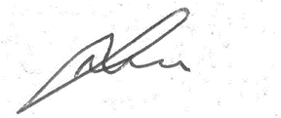

**Luke Hands**  DProf, MSc, BSc (Hons), PIEMA, AIOSH, CQP MCQI

**Director of Health, Safety, Environmental & Quality**

](https://henryconstruction.co.uk/)

**Henry Construction Projects Limited**

Parkway Farm, Church Road, Cranford, Hounslow, TW5 9RY

**Mobile:** +44 (0) 7810822172  
**E-mail:** [Lhands@henryconstruction.co.uk](mailto:Lhands@henryconstruction.co.uk)

